**How is university students’ paid work associated with their locus of control?**

**Supplementary Material**

**Section A:** How involvement in paid work is measured for university students in Next Steps data

The questionnaire was structured in two ways to capture student work. The first way was through a retrospective question “Since you started university, have you done any paid work during term-time/ Christmas/ Easter?”. All students who had finished their academic term, or students without a current job who had not finished their academic term were asked this question. Conditional on whether or not they had worked, their average weekly hours were derived from the question “In a normal week during term time/ Christmas/ Easter for how many hours on average did you do paid work?”.

The second way was through, let’s call it, a “current” question. Regardless of whether or not they had finished their academic term, students also reported whether they currently had a job at the time of the interview and the hours they usually worked in the job each week, including overtime. The question routing error missed students who currently had a job but had not finished their academic term. In other words, students who were working during term-time at the time of interview are missing their employment history about the previous Christmas or Easter.

Acknowledging this routing problem, I measure four periods in which students do paid work; term-time, Summer, Easter and Christmas. I define term-time work as students who answered “yes” to the retrospective question for term-time work, and those who currently had a job and had not yet finished their academic term. Work during Summer holidays is measured as students who currently had a job and had finished their academic term. I use the term “Summer” because two thirds of students who had finished their academic term were interviewed between May and July. Finally, work at Christmas and Easter only refers to students who answered the retrospective question, who constituted 92% of the full sample.

**Fig. S.1** Question routing of work during university in the Next Steps data.

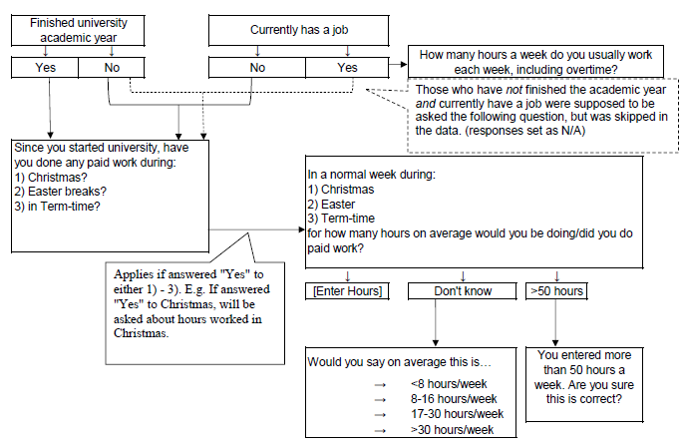

Note: Information is processed according to author’s discretion, following question routing in the Next Steps questionnaire (UCL, 2021).

**Section B: Supplementary Tables on descriptive statistics**

**Table S.1.** Percentage of students who worked by period

|  |  |
| --- | --- |
| Period worked | (%) |
| Ever worked | 58 |
| Sample for Summer and term-time |  |
| None | 54 |
| Only during term-time | 20 |
| Only during Summer | 11 |
| Both during term-time and Summer | 15 |
| Observations | 2,426 |
| Retrospective responses only |  |
| None | 46 |
| Only during term-time | 3 |
| Only in holidays | 25 |
| Both during term-time and holidays | 26 |
| Observations | 2,230 |

Note: Holidays here refer to Summer, Christmas, and Easter.

**Table S.2.** Differences in average characteristics between complete sample and sample which contain at least one missing response to LOC

|  |  |  |  |
| --- | --- | --- | --- |
|  | Complete  (a) | Missing  (b) | Diff  (a)-(b) |
| Ever worked | 0.52 | 0.58 | -0.057* |
| Work during term-time | 0.32 | 0.35 | -0.030 |
| Work during Summer | 0.25 | 0.30 | -0.055** |
| Worked during Christmas | 0.34 | 0.38 | -0.038 |
| Worked during Easter | 0.28 | 0.34 | -0.064** |
| Sex: Male | 0.40 | 0.47 | -0.075*** |
| Ethnicity: White | 0.58 | 0.65 | -0.065** |
| Health problem or disability at Wave 7 | 0.06 | 0.07 | -0.013 |
| Receives a financial help with university costs | 0.65 | 0.62 | 0.023 |
| Wave enrolled in university | 0.74 | 0.71 | 0.028 |
| Attending a Russell Group University | 0.23 | 0.26 | -0.034 |
| Main parent has higher education | 0.38 | 0.41 | -0.031 |
| Lone parent/no parent family | 0.16 | 0.15 | 0.003 |
| Number of siblings | 1.88 | 1.78 | 0.104 |
| Observations | 2426 | 593 |  |

Note: * p < 0.10, ** p < 0.05, *** p < 0.01. Asterisks indicate the p-values for the t-test in difference of means between the complete sample (a) and the sample excluded (b) because of responses of “Don’t know” to at least one item in the locus of control questions.

**Table S.3:** Average characteristics of students' background by work status in term-time and Summer

|  |  |  |  |  |  |  |
| --- | --- | --- | --- | --- | --- | --- |
|  | Term-time | | | Summer | | |
|  | Not worked | Worked | Diff | Not worked | Worked | Diff |
|  | (a) | (b) | (a)-(b) | (c) | (d) | (c)-(d) |
| Standardised locus of control, wave 7 | -0.00 | 0.06 | -0.05 | 0.00 | 0.05 | -0.06* |
| Locus of control, wave 7 | 11.18 | 11.39 | -0.15* | 11.21 | 11.35 | -0.12 |
| Student characteristics |  |  |  |  |  |  |
| Sex: Male | 0.50 | 0.41 | 0.10*** | 0.48 | 0.44 | 0.04* |
| Ethnicity: White | 0.82 | 0.84 | -0.04 | 0.83 | 0.83 | 0.02 |
| Health problem or disability at Wave 7 | 0.09 | 0.06 | 0.02 | 0.09 | 0.06 | 0.02* |
| Receives financial help for university costs | 0.55 | 0.63 | -0.07*** | 0.56 | 0.61 | -0.05* |
| Enrolled in wave 6 | 0.66 | 0.79 | -0.11*** | 0.69 | 0.73 | -0.04* |
| Attending a Russell Group University | 0.32 | 0.22 | 0.10*** | 0.34 | 0.18 | 0.15*** |
| Science subject | 0.42 | 0.32 | 0.08*** | 0.42 | 0.30 | 0.12*** |
| Family background |  |  |  |  |  |  |
| Main parent has higher education | 0.49 | 0.39 | 0.07*** | 0.49 | 0.37 | 0.10*** |
| Lone parent/no parent family | 0.14 | 0.17 | -0.03 | 0.14 | 0.17 | -0.03 |
| Number of siblings | 1.62 | 1.57 | 0.09 | 1.60 | 1.60 | -0.04 |
| Propensity to work, age 15/16 |  |  |  |  |  |  |
| Household managing quite well with income | 0.68 | 0.62 | 0.04 | 0.67 | 0.63 | 0.02 |
| Ever received EMA | 0.32 | 0.36 | -0.02 | 0.32 | 0.38 | -0.06** |
| Attitude towards school (scale 0-48) | 35.67 | 35.43 | 0.31 | 35.82 | 35.06 | 0.63* |
| House is owned/on mortgage/shared ownership | 0.88 | 0.88 | -0.01 | 0.88 | 0.87 | 0.03 |
|  | 1572 | 854 | 2426 | 1687 | 739 | 2426 |

Note: * p < 0.10, ** p < 0.05, *** p < 0.01. p-values are for the t-test to examine differences between groups (a) and (b) and (c) and (d).

**Table S.4:** Average characteristics of students' background by work status in Christmas and Easter

|  |  |  |  |  |  |  |
| --- | --- | --- | --- | --- | --- | --- |
|  | Christmas | | | Easter | | |
|  | Not worked | Worked | Diff | Not worked | Worked | Diff |
|  | (a) | (b) | (a)-(b) | (c) | (d) | (c)-(d) |
| Standardised locus of control, wave 7 | -0.00 | 0.03 | -0.04 | 0.01 | 0.01 | 0.00 |
| Locus of control, wave 7 | 11.19 | 11.32 | -0.15* | 11.22 | 11.27 | -0.02 |
| Student characteristics |  |  |  |  |  |  |
| Sex: Male | 0.51 | 0.43 | 0.08*** | 0.51 | 0.44 | 0.05* |
| Ethnicity: White | 0.80 | 0.85 | -0.09*** | 0.80 | 0.86 | -0.11*** |
| Health problem or disability at Wave 7 | 0.09 | 0.06 | 0.02* | 0.09 | 0.06 | 0.02* |
| Receives financial help for university costs | 0.56 | 0.61 | -0.03 | 0.58 | 0.58 | -0.00 |
| Enrolled in wave 6 | 0.67 | 0.73 | -0.05* | 0.67 | 0.73 | -0.05* |
| Attending a Russell Group University | 0.33 | 0.22 | 0.11*** | 0.32 | 0.23 | 0.09*** |
| Science subject | 0.41 | 0.35 | 0.07*** | 0.41 | 0.34 | 0.06** |
| Family background |  |  |  |  |  |  |
| Main parent has higher education | 0.50 | 0.38 | 0.07*** | 0.49 | 0.39 | 0.05* |
| Lone parent/no parent family | 0.15 | 0.15 | -0.00 | 0.15 | 0.13 | 0.02 |
| Number of siblings | 1.63 | 1.58 | 0.10 | 1.64 | 1.56 | 0.15** |
| Propensity to work, age 14/15 |  |  |  |  |  |  |
| Household managing quite well with income | 0.65 | 0.68 | -0.04* | 0.65 | 0.68 | -0.06** |
| Ever received EMA | 0.34 | 0.33 | 0.03 | 0.35 | 0.31 | 0.06* |
| Attitude towards school (scale 0-48) | 35.46 | 35.70 | -0.25 | 35.60 | 35.46 | 0.29 |
| House is owned/on mortgage/shared ownership | 0.87 | 0.89 | -0.04* | 0.87 | 0.90 | -0.04** |
|  | 1385 | 845 | 2230 | 1479 | 751 | 2230 |

Note: * p < 0.10, ** p < 0.05, *** p < 0.01. p-values are for the t-test to examine differences between groups (a) and (b) and (c) and (d).

**Table S.5.** Estimates using inverse probability weighting

|  |  |  |  |  |  |
| --- | --- | --- | --- | --- | --- |
|  | Ever | Term-time | Summer | Christmas | Easter |
| Worked | 0.080* (0.044) | 0.103** (0.045) | 0.067 (0.047) | 0.045 (0.045) | 0.002 (0.047) |
| LOC age 15/16 | 0.290*** (0.024) | 0.307*** (0.025) | 0.296*** (0.026) | 0.305*** (0.024) | 0.298*** (0.026) |
| Observations | 2426 | 2426 | 2426 | 2230 | 2230 |

Note: * p < 0.10, ** p < 0.05, *** p < 0.01. Standard errors are reported in parentheses. All information are obtained from wave 7 when the young person was aged 20/21 unless otherwise stated. Observations shown is raw sample size, but estimates are obtained using wave 7 population probability weights and accounting for clustering at the school level. The covariates used to predict work are sex, propensity to work characteristics, family background characteristics, wave enrolled in university and whether received grant for university. All estimates control for individual and family background characteristics.

**Table S.6.** Baseline estimates, using multiple imputation

|  |  |  |  |  |  |
| --- | --- | --- | --- | --- | --- |
|  | Ever | Term-time | Summer | Christmas | Easter |
| Worked | 0.097**  (0.039) | 0.101***  (0.037) | 0.084**  (0.041) | -0.041  (0.049) | -0.044  (0.051) |
| LOC age 15/16 | 0.241***  (0.021) | 0.241***  (0.021) | 0.241***  (0.021) | 0.180***  (0.033) | 0.179***  (0.033) |
| Observations | 3,543 | 3,543 | 3,543 | 3,217 | 3,217 |

Note: * p < 0.10, ** p < 0.05, *** p < 0.01. Standard errors are reported in parentheses. All information are obtained from wave 7 when the young person was aged 20/21 unless otherwise stated. Observations shown is raw sample size, but estimates are obtained using wave 7 population probability weights and accounting for clustering at the school level. Estimates for Christmas and Easter incorporated listwise deletion first due to question routing error (see Section A above), followed by multiple imputation. 20 imputations were run.

**Section C: Supplementary Figures on descriptive statistics**

**Fig. S.2** Bar charts showing the percentage of students working during term-time, by university subject at wave 7

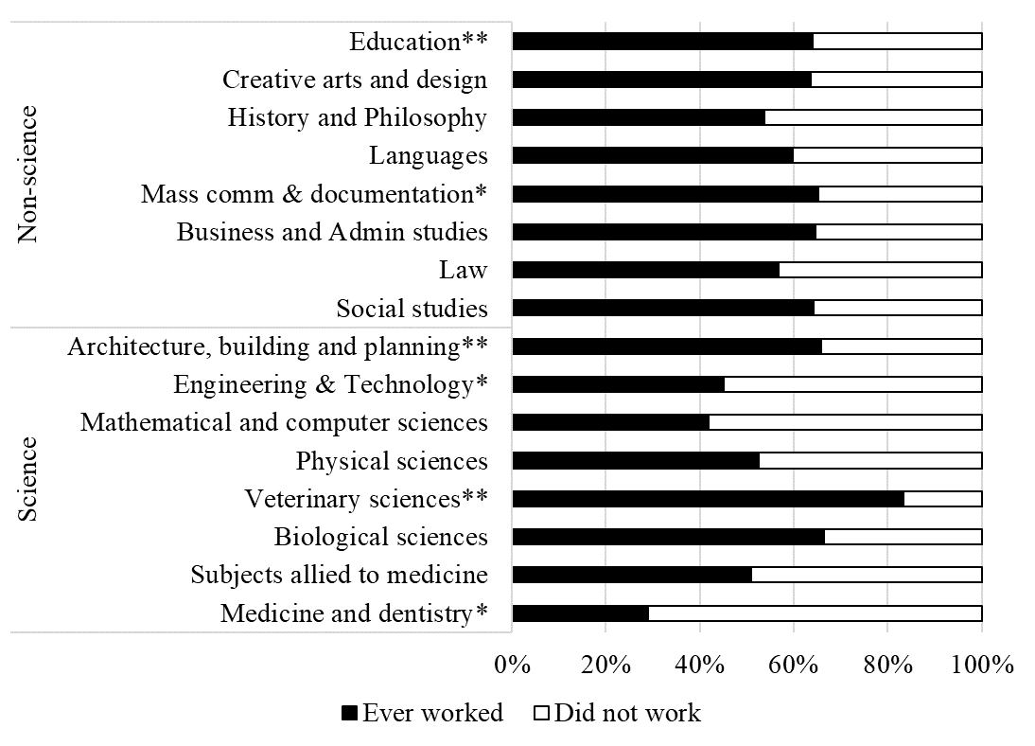

Note: *Refers to subjects with less than 100 students and **refers to subjects with less than 50 students. Non-science and Science subjects as defined by the Higher Education Statistics Agency (HESA).

**Fig. S.3** Bar charts showing the proportion of students in paid work by subject and sex



Note: Subjects as defined by the HESA. Subjects included in Science are 1) Medicine and Dentistry 2) Subjects allied to medicine 3) Biological Sciences 4) Veterinary sciences, agriculture and related subjects 5) Physical Sciences 6) Mathematical and computer sciences 7) Engineering 8) Technologies 9) Architecture, building and planning. Subjects in Non-Science are 1) Social Studies 2) Law 3) Business and administrative studies 4) Mass and communications and documentation 5) Linguistics, classics and related subjects 6) European languages, literature and related subjects 7) Eastern, Asiatic, African, American and Australasian languages, literature and related subjects 8) Historical and Philosophical studies 9) Creative arts and design 10) Education.